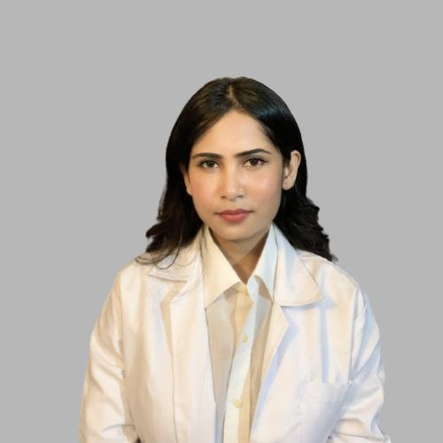
Dr. Kangkana Goswami (PT),
Assistant Professor, Department of Physiotherapy, RGU
Qualification:
Masters in Musculoskeletal and Sports Conditions from Rajiv Gandhi University of Health and Sciences, Bangalore (2019-2021)
Bachelors in Physiotherapy from Assam Down University, Guwahati (2014-2018)
Work Experience:
- Physiotherapy Centre (Pain and Sports Injury Clinic), Guwahati (Jan 2021-Present)
- Royal Global University (since Feb 2023)
Publications: 2
- Post-operative rehabilitation of fracture of distal end of radius: A case study, IJARIIT, 2021
- Impact of smartphone usage on the quality of treatment provided by the physiotherapists and physiotherapy interns in the out-patient department, IJCRR, 2022
Personal Training/Internship:
Hospital/Clinic | Designation | Duration
ESIC Hospital, Bangalore | Masters in Physical Therapy (Training) | 2019-2021
Padmashree Diagnostics, Bangalore | Masters in Physical Therapy (Training) | 2019-2021
Padmashree Clinic, Bangalore | Masters in Physical Therapy (Training) | 2019-2021
Fortis Hospital, Bangalore | Bachelor’s in Physiotherapy (Training) | July, 2018-Nov, 2018
Mobility India, Bangalore | Bachelor’s in Physiotherapy (Training) | Dec, 2018

Certificates:
- Manual Therapy, FIMT under Dr. Peralson Kanasabapathy (MPT AUS), held at Padmashree Clinic, Bangalore 2021
- Dry Needling (Basic and Advance) under Dr. David Kumar Arun J, held at Vasavi Hospital, Bangalore.

